Docker - Public Repositories

Public repositories can be used to host Docker images which can be used by everyone else. An example is the images which are available in Docker Hub. Most of the images such as Centos, Ubuntu, and Jenkins are all publicly available for all. We can also make our images available by publishing it to the public repository on Docker Hub.

For our example, we will use the **myimage** repository built in the "Building Docker Files" chapter and upload that image to Docker Hub. Let’s first review the images on our Docker host to see what we can push to the Docker registry.

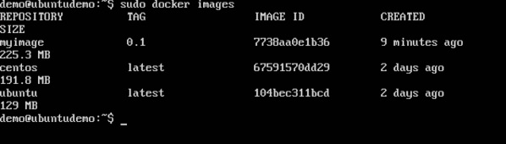

Here, we have our **myimage:0.1** image which was created as a part of the “Building Docker Files” chapter. Let’s use this to upload to the Docker public repository.

The following steps explain how you can upload an image to public repository.

**Step 1** − Log into Docker Hub and create your repository. This is the repository where your image will be stored. Go to <https://hub.docker.com/> and log in with your credentials.

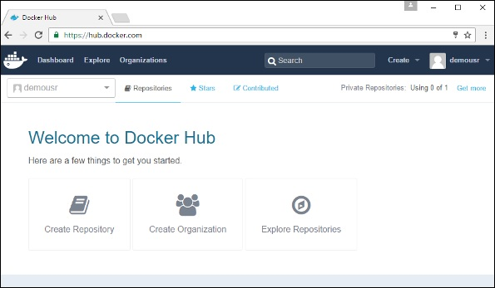

**Step 2** − Click the button "Create Repository" on the above screen and create a repository with the name **demorep**. Make sure that the visibility of the repository is public.

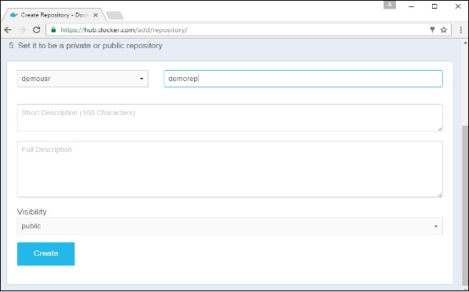

Once the repository is created, make a note of the **pull** command which is attached to the repository.

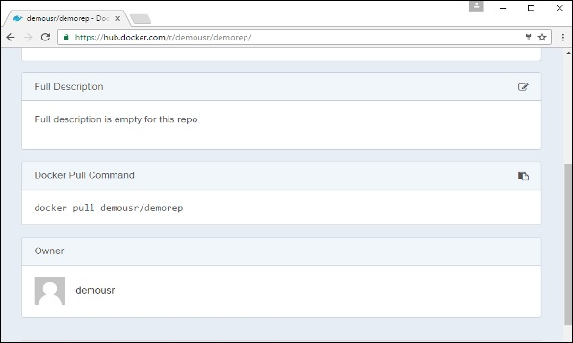

The **pull** command which will be used in our repository is as follows −

docker pull demousr/demorep

**Step 3** − Now go back to the Docker Host. Here we need to tag our **myimage** to the new repository created in Docker Hub. We can do this via the Docker **tag command**.

We will learn more about this **tag command** later in this chapter.

**Step 4** − Issue the Docker login command to login into the Docker Hub repository from the command prompt. The Docker login command will prompt you for the username and password to the Docker Hub repository.

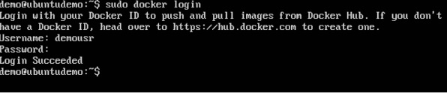

**Step 5** − Once the image has been tagged, it’s now time to push the image to the Docker Hub repository. We can do this via the Docker **push** command. We will learn more about this command later in this chapter.

docker tag

This method allows one to tag an image to the relevant repository.

Syntax

docker tag imageID Repositoryname

Options

* **imageID** − This is the ImageID which needs to be tagged to the repository.
* **Repositoryname** − This is the repository name to which the ImageID needs to be tagged to.

Return Value

None

Example

sudo docker tag ab0c1d3744dd demousr/demorep:1.0

Output

A sample output of the above example is given below.

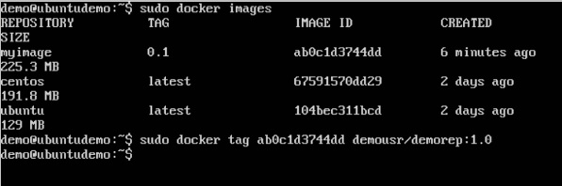

docker push

This method allows one to push images to the Docker Hub.

Syntax

docker push Repositoryname

Options

* **Repositoryname** − This is the repository name which needs to be pushed to the Docker Hub.

Return Value

The long ID of the repository pushed to Docker Hub.

Example

sudo docker push demousr/demorep:1.0

Output

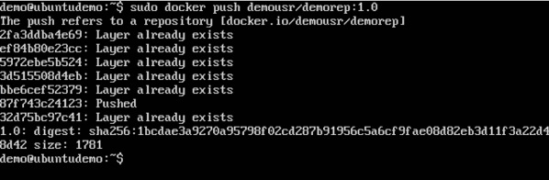

If you go back to the Docker Hub page and go to your repository, you will see the tag name in the repository.

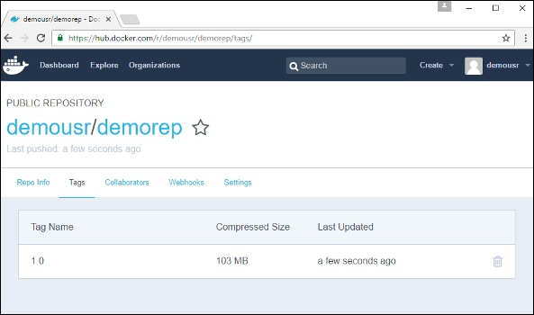

Now let’s try to pull the repository we uploaded onto our Docker host. Let’s first delete the images, **myimage:0.1** and **demousr/demorep:1.0**, from the local Docker host. Let’s use the Docker **pull command** to pull the repository from the Docker Hub.

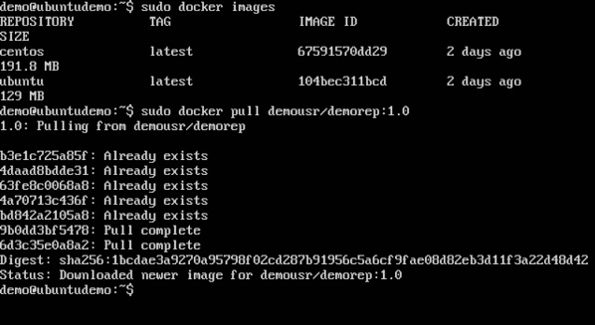

From the above screenshot, you can see that the Docker **pull** command has taken our new repository from the Docker Hub and placed it on our machine.